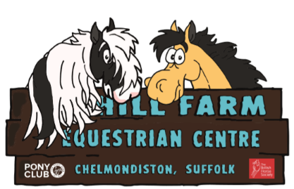

Around The Yard Word Scramble
Try unscrambling these words from around the yard.

EOSH | _________ | AHEELBROWRW | _________
SGVHINAS | _________ | SLATBE | _________
SKPI | _________ | ROFK | _________
TMCKORAO | _________ | MROOB | _________
HEANYT | _________ | ATRSW | _________
WABEER UCKTT | _________ | FROE EODM | _________
RUT OUGNRUT | _________ | SVOELH | _________

